Oscillator
# Source: Chatgpt (GPT-5-Mini) at [1/23/2026]
An oscillator is an electronic component or circuit that produces a repetitive, oscillating signal, usually in the form of a sine wave, square wave, or radio frequency (RF) signal.
In simple terms:
🔁 An oscillator generates a steady repeating signal, like a wave, without needing an input signal.

🔧 What Does an Oscillator Do?
# Source: Chatgpt (GPT-5-Mini) at [1/23/2026]
An oscillator creates frequencies used in many systems like:
- 📡 Radio transmitters (to generate carrier waves)
- ⌚ Digital clocks and watches (to keep accurate time)
- 📱 Microprocessors (to set internal timing – clock signal)
- 📶 Communication systems (to control signal frequency)

📈 Types of Oscillators:
# Source: Chatgpt (GPT-5-Mini) at [1/23/2026]
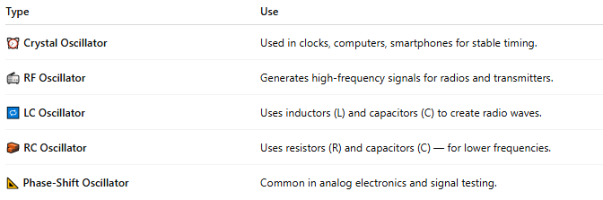

Type | Use
⏰ Crystal Oscillator | Used in clocks, computers, smartphones for stable timing.
📻 RF Oscillator | Generates high-frequency signals for radios and transmitters.
🔁 LC Oscillator | Uses inductors (L) and capacitors (C) to create radio waves.
🧱 RC Oscillator | Uses resistors (R) and capacitors (C) — for lower frequencies.
📐 Phase-Shift Oscillator | Common in analog electronics and signal testing.

⚙️ How It Works (Basic Concept):
# Source: Chatgpt (GPT-5-Mini) at [1/23/2026]
- Energy is stored and released in circuit components (like capacitors and inductors).
- This creates a continuous, repeating wave.
- The wave is output as a signal with a fixed frequency.
Example: In a radio transmitter, an oscillator generates a high-frequency signal (e.g., 100 MHz), which becomes the carrier wave that carries your voice or music.

🧠 Real-Life Examples:
# Source: Chatgpt (GPT-5-Mini) at [1/23/2026]
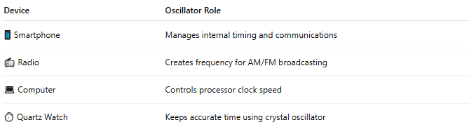

Device | Oscillator Role
📱 Smartphone | Manages internal timing and communications
📻 Radio | Creates frequency for AM/FM broadcasting
💻 Computer | Controls processor clock speed
⏱️ Quartz Watch | Keeps accurate time using crystal oscillator

📖 Summary:
# Source: Chatgpt (GPT-5-Mini) at [1/23/2026]
An oscillator is a device or circuit that creates a repeating electronic signal, essential for timing, frequency control, and wireless communication. It’s the heartbeat of many modern electronic systems.

